Copyright for test papers and marking guides remains with West Australian Test Papers.
Test papers may only be reproduced within the purchasing school according to the advertised Conditions of Sale.
Test papers should be withdrawn after use and stored securely in the school until Friday 1st December 2017.



SEMESTER TWO

MATHEMATICS
SPECIALIST
UNITS 1 & 2

2017

SOLUTIONS

Calculator−free Solutions

1. (a) 1000 = 310 + 650 + 440 – 170 – 150 – 180 + x
x = 100
(b) 150 – 100 = 50
(c) (i) 44
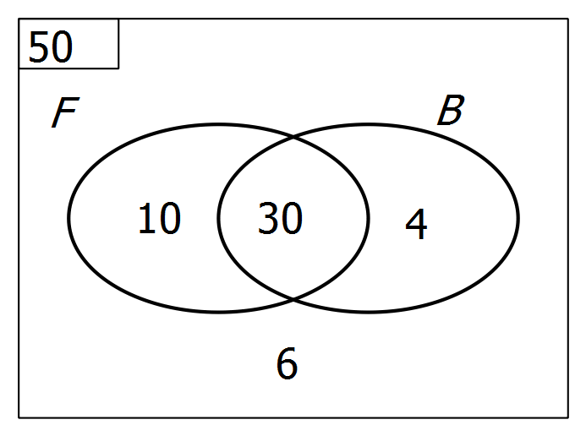 (ii)

∴ n(B) = 34 [6]

2. (a) (i) Substitute z = 2i to get (2i)⁴ – 2(2i)³ + 7(2i)² –8(2i) + 12
which reduces to 0
(ii) z = –2i (the conjugate) is the other root.
(b)
∴ 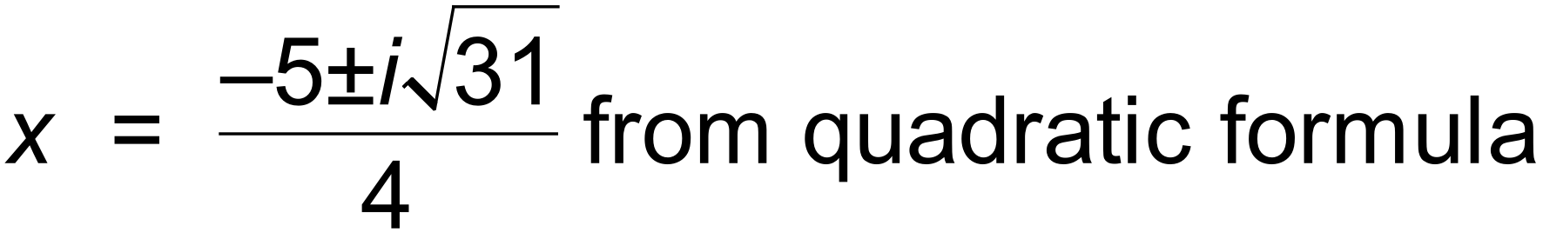 [5]

3. (a) (i)
(ii) 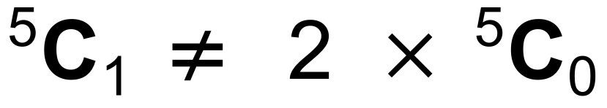 This statement is false
(b) (i) 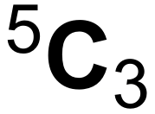 = 10
(ii) 2 x 4! = 48 [8]

4. (a) p = 4, q = 0.2
(b) y = 1 – x becomes y = 4[ 1 – 0.2 x]
i.e. y = 4 – 0.8x
or, if (c) is done before (b), gradient is – 0.8 and intercept is 4
∴ y = 4 – 0.8x
(c) A′ = ( 5, 0 ) and B′ = ( 0, 4 )
(d) 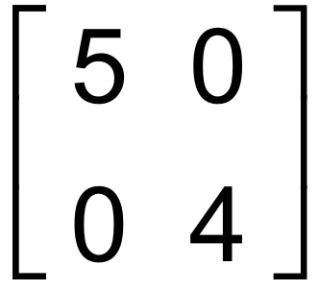
(e) 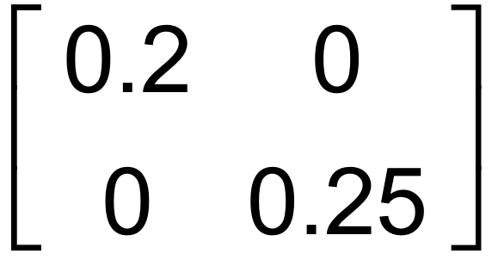
(f) Reflection across y axis
i.e. g(x) becomes – g(x)
(g) A = 0.5 ( ms – rn ) [12]

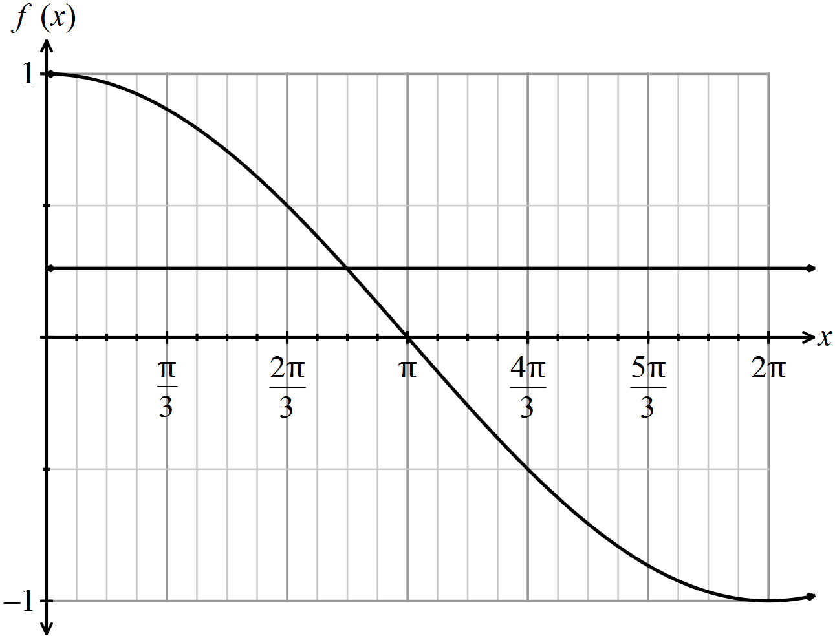5. (a)

(b) 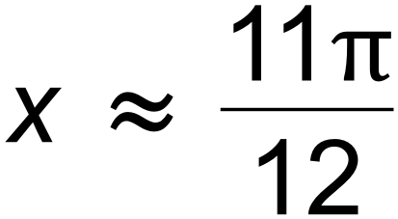line
of intersection and accuracy
(c) sin x
(d) 2cos x . sin x = sin 2x [8]

6. (a) Let the numbers be 2k – 1, 2k + 1, 2k + 3, 2k + 5, 2k + 7
2k − 1 + 2k + 1 + 2k + 3 + 2k + 5 + 2k + 7
= 10k + 15
Since 10k + 15 = 5(2k + 3) then divisible by 5.
(b) Assume that 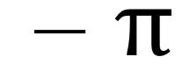 is rational, hence  = 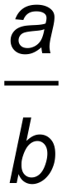
∴ 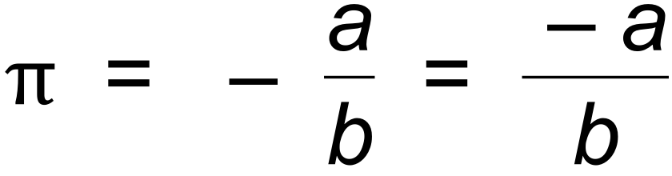
But – a and b are integers, so  is rational.
This contradicts the supposition, and
therefore by contradiction  must be irrational. [7]

7. For 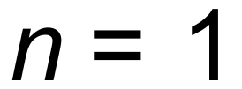:
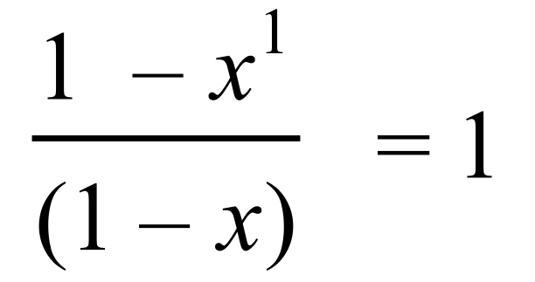 ∴ True for n = 1
Assume true for 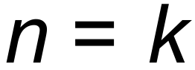:
ie 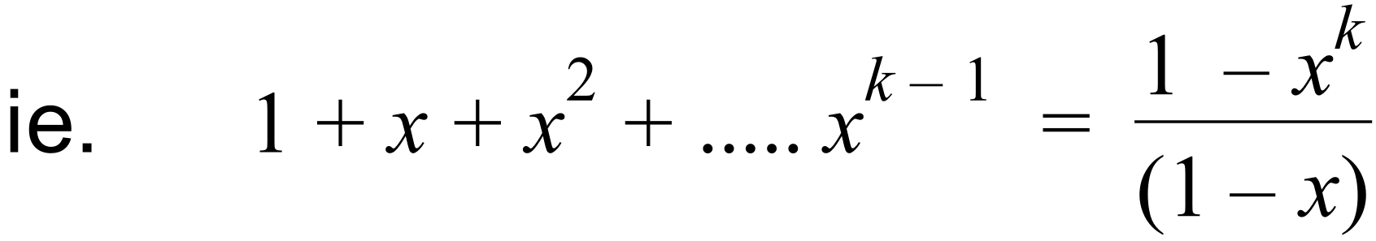
Prove true for 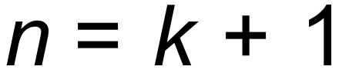:
Proof: 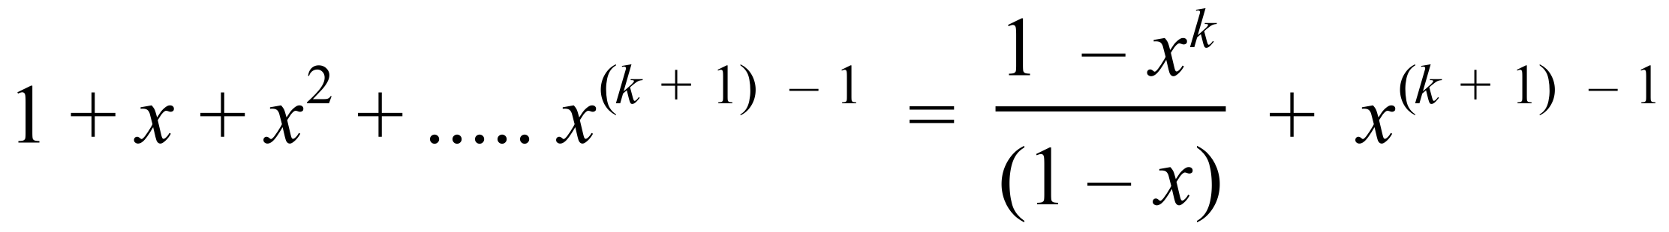
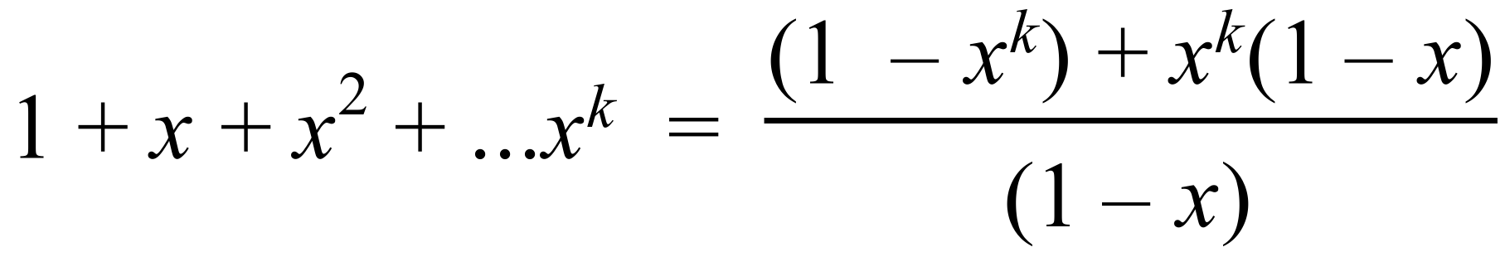
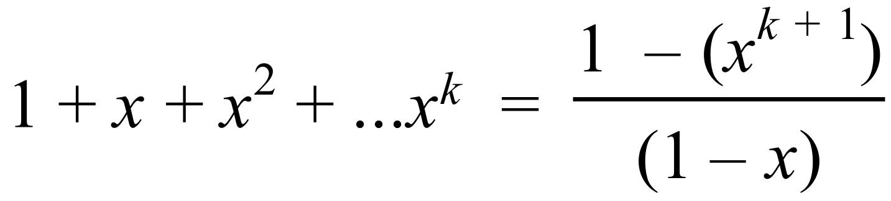 as required
Therefore, True for n = k + 1, and since true for n =1,
true for all whole numbers. [5]

Calculator−assumed Solutions

8. wz = (2 + ai)(3b + i) = 4
∴ 6b + 2i + 3abi – a = 4
∴ 6b – a = 4 and 2 + 3ab = 0
∴ 2 +3(6b – 4)(b) = 0
∴ 9b² – 6b +1 = 0
∴ b =  and a = –2 [5]

9. (a) RHS = 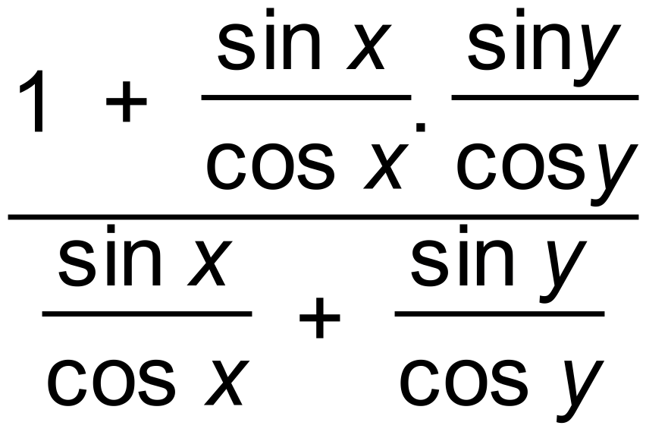
= 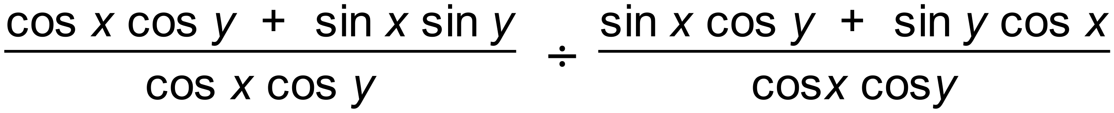
= 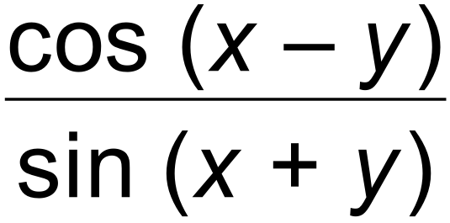 = LHS
(b) (i)
and
=
= |p| |q| [ cos A cos B + sin A sin B ]
(ii) cos(A + B) = cos(A – (–B)) = cos A cos (–B) + sin A sin (–B)
= cos A cos B – sin A sin B
(iii) cos² A + [cos(120 + A)]² +[cos(120– A)]²
= cos² A + [cos 120cos A – sin120sin A]² +[cos120cos A + sin120sin A]²
= cos² A + [ 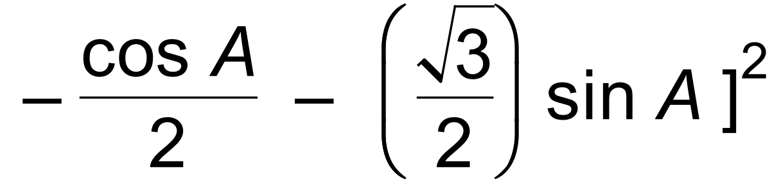 + [ 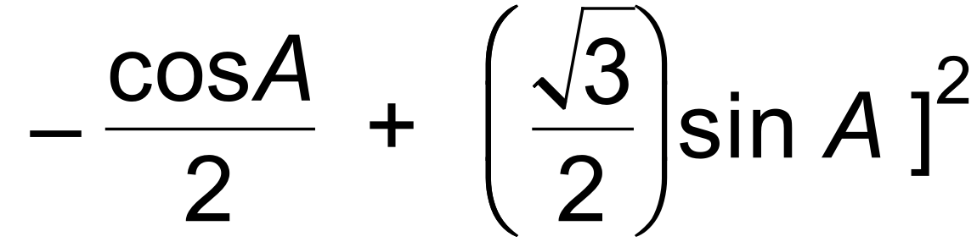
= 1.5 cos² A + 1.5 sin² A
= 1.5 [13]
10. (a) (3a – b)  (a + 3b) = 3a  a – b  a + 9a  b – 3b  b
= 3|a|² + 8ab – 3|b|²
= 3 + 8|a||b|cos 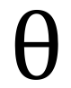 – 3
= 8cos as required
(b) 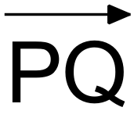 = (4,1)
Unit vector on x axis = (1,0)
Length of projection = | PQ. 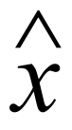 | = |4| = 4 [7]

11. (a) Let the cost of a bottle of orange concentrate cost x
Let the cost of a bottle of banana concentrate cost y
5x + 1y = 19
2x + 3y = 18
(b) 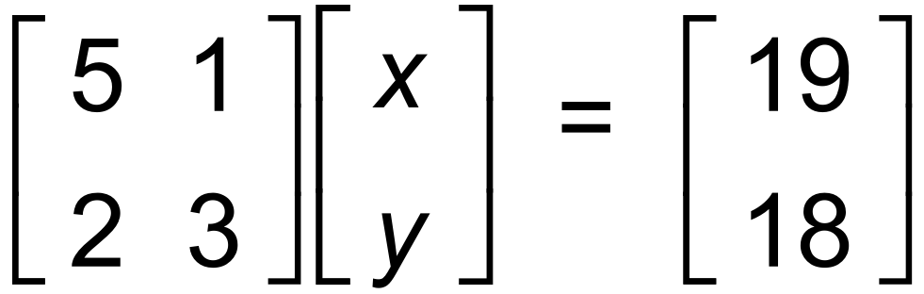
∴ 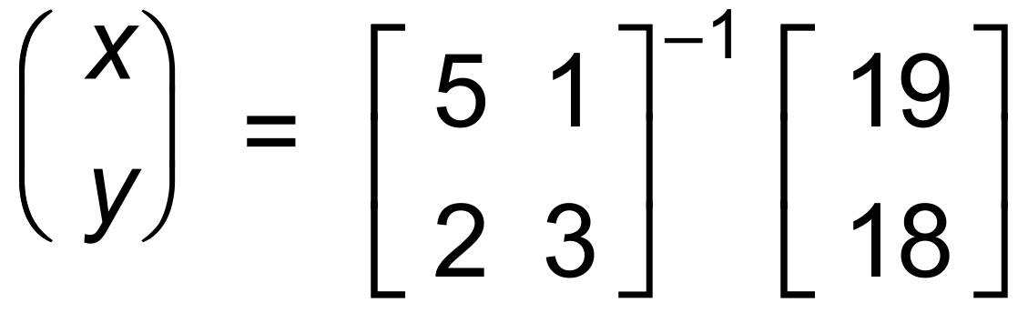
= 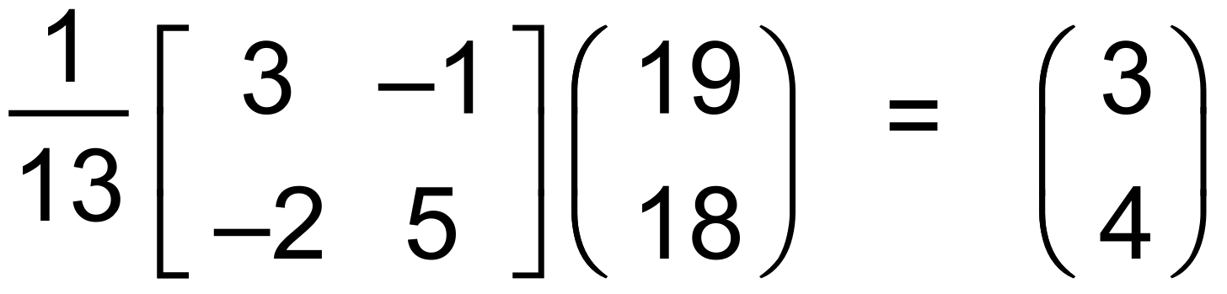 [4]

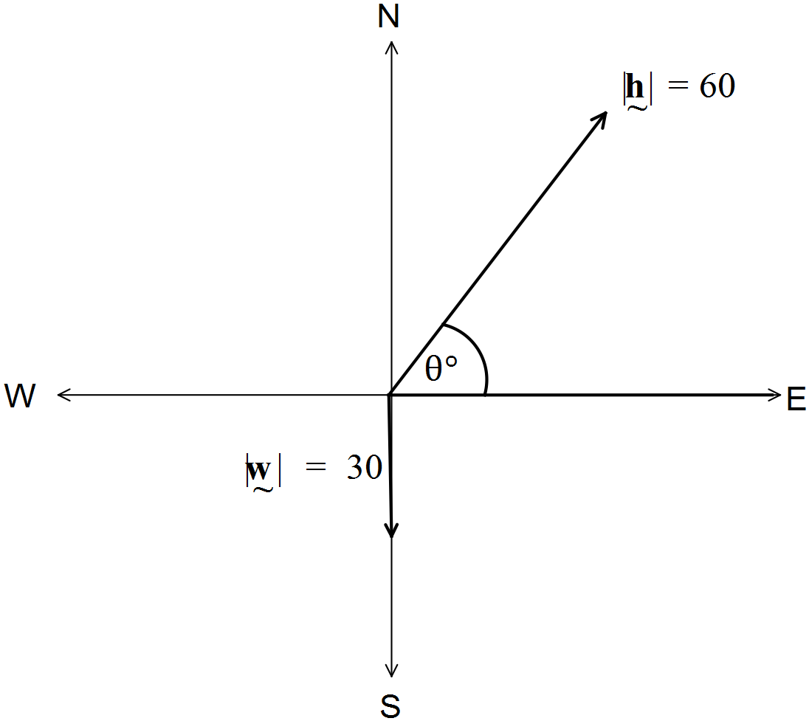12. (a)

(b) 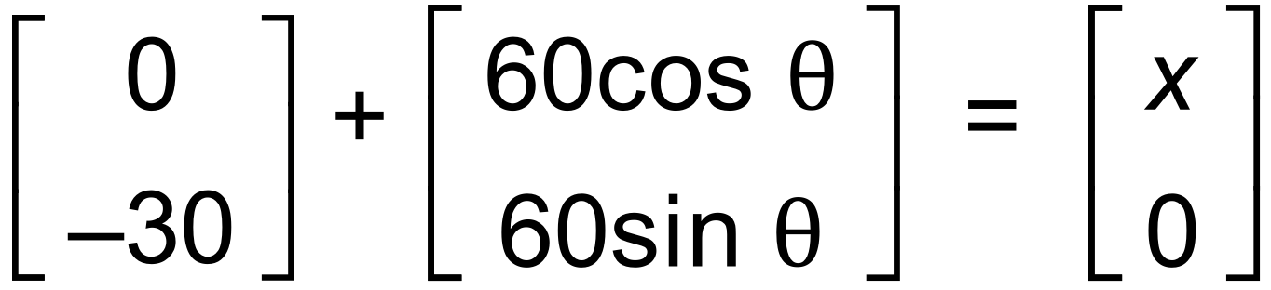
∴ 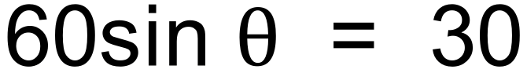
∴ 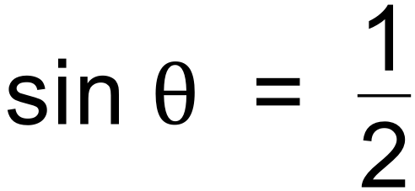
∴ = 30   Bearing is 060 T
(c) Speed in Easterly direction is 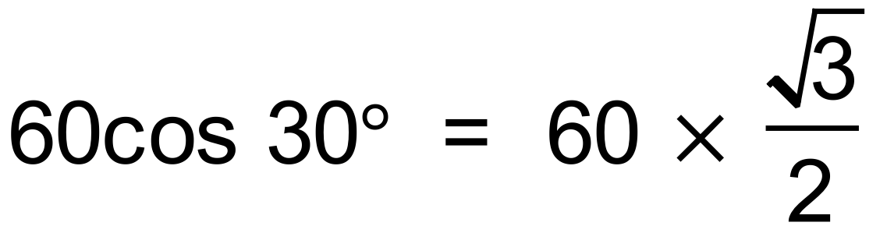
Time taken is 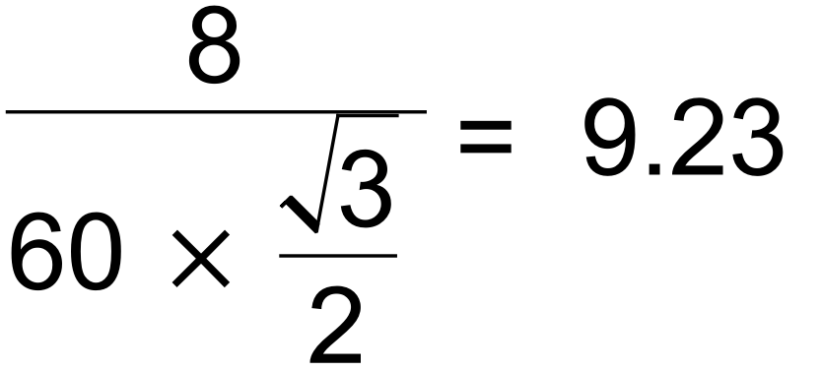 minutes [8]

13. (a) (i) ∴ Rotation of 180°
(ii) ∴ Rotation of 270° clockwise

(b) P = 6(B – 2A) x B ^{–1}
∴ 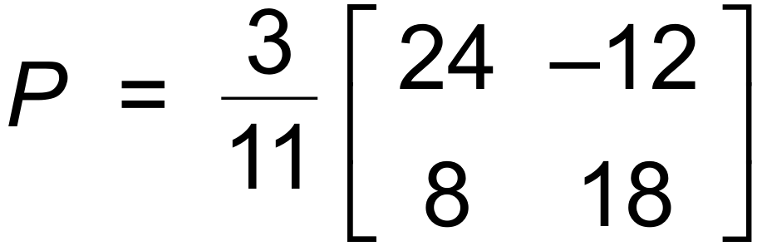
(c) BA = 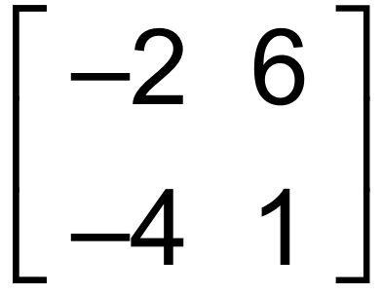
BAX = 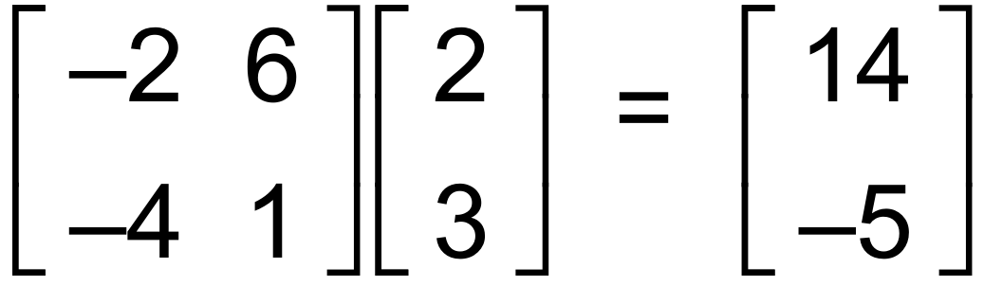
Co−ordinates are (14, −5)
(d) Det B = 22 ∴ Area = 25 x 22 = 550
(e) Singular matrix has det = 0
∴ Area = 0 i.e. A line [13]

14. (a) 3(2i + 3j) – (mi – 5j) = 8i + 14j
∴ (6 – m)i + 14j = 8i + 14j
∴ 6 – m = 8
∴ m = – 2
(b) 2i + 3j = k(mi – 5j)
∴ 2 = km and 3 = –5k
∴ k = – 0.6 and by substitution, m = 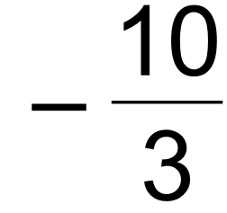
(c) 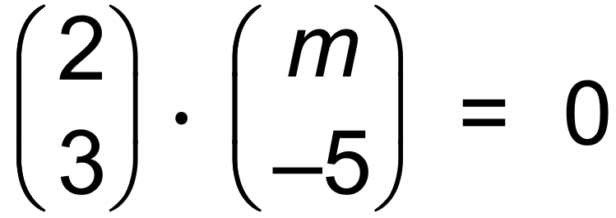
∴ 2m – 15 = 0
∴ m = 7.5 [6]

15. (a)
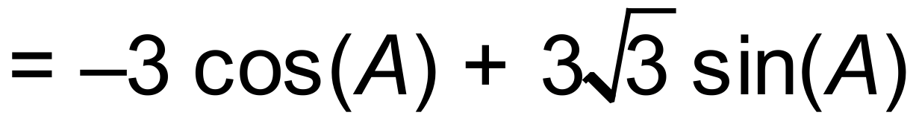
hence, 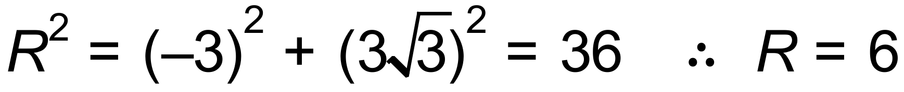
and 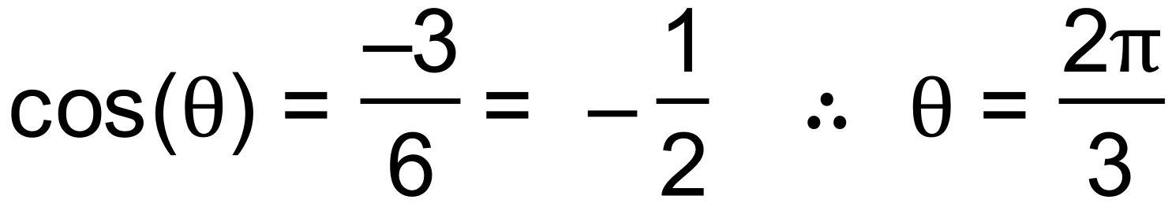
therefore, 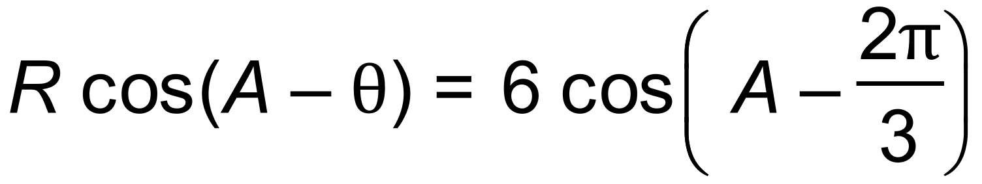
(b) (i) 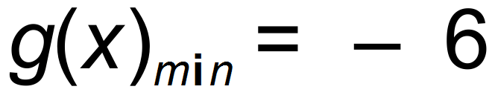
(ii) for 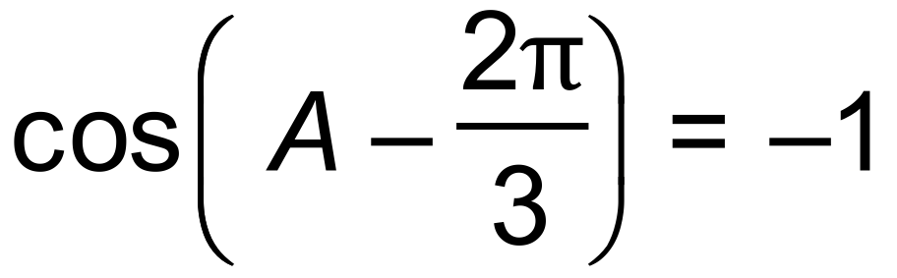
hence 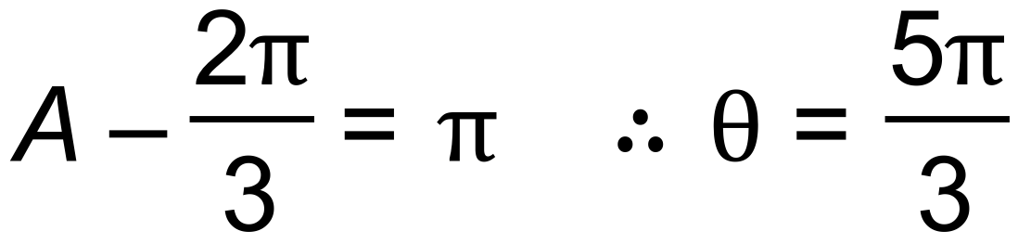 [7]

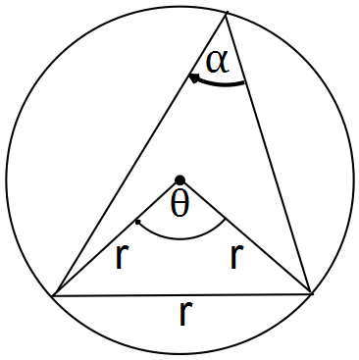
16. (a) 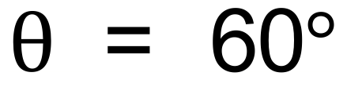 (equilateral triangle)
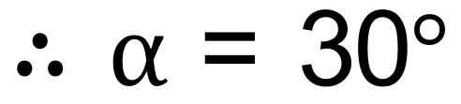 (central angle theorem)

(b) (i)

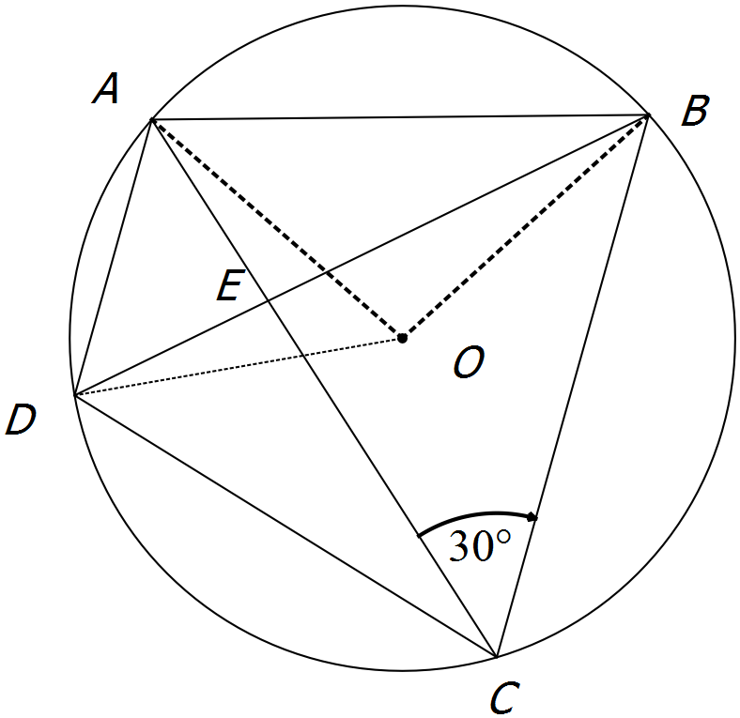
AOB = 60 (proved in (a))
 (theorem)
Similarly, DBC = 30

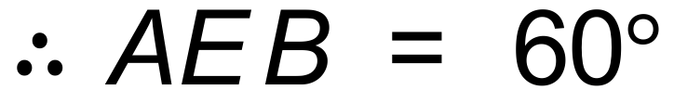

(ii) Assume E is the centre.
All angles of ABE = 60 
and all angles of BEC = 60 
But 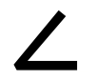AEB = 2ACB which is impossible if they are both 60 
 E is not the centre. [8]

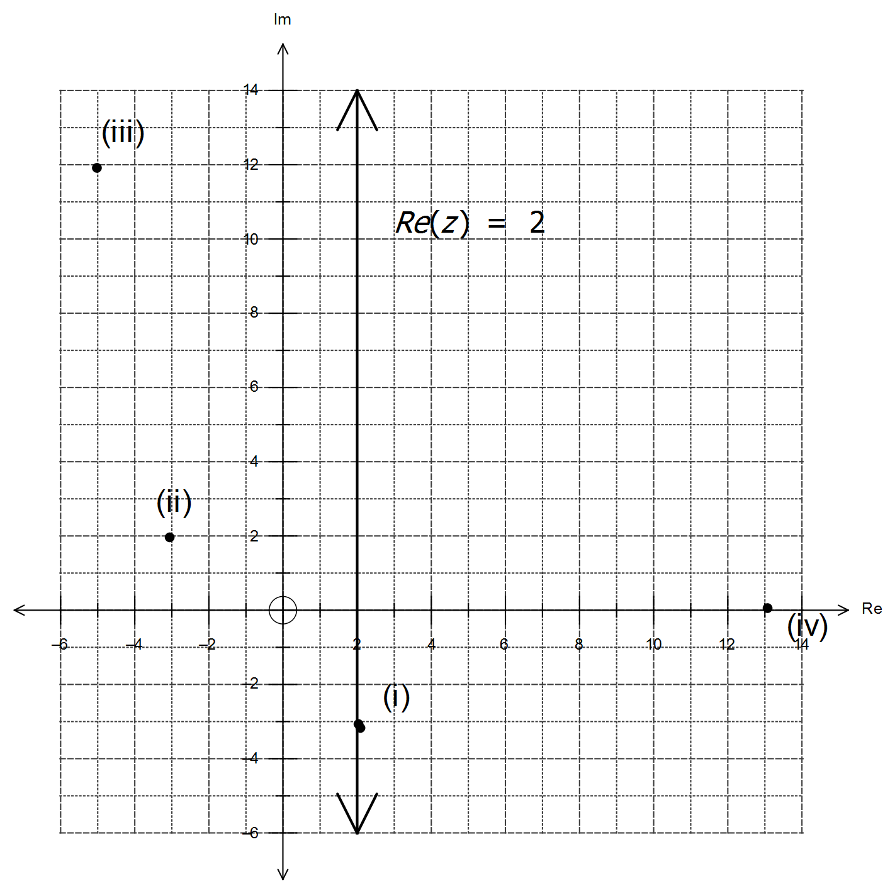
17. 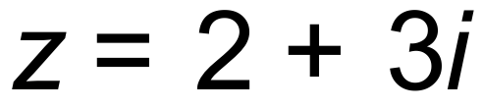
(i) 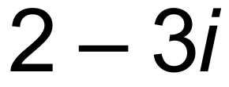

(ii) 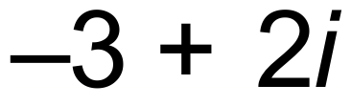
(iii) 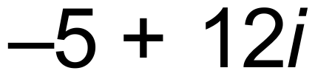
(iv) 13

[8]
18. (a) 2m
(b) 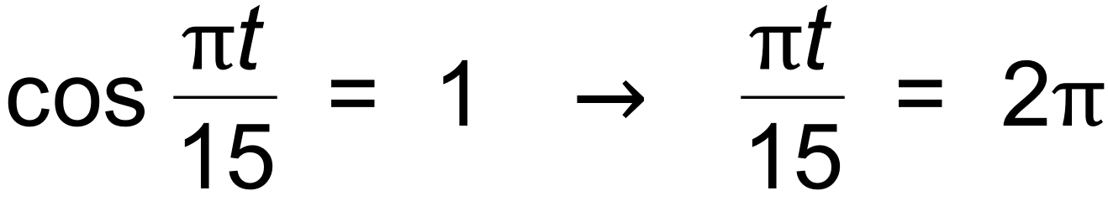
∴ t = 30 secs
(c) 138m
(d) 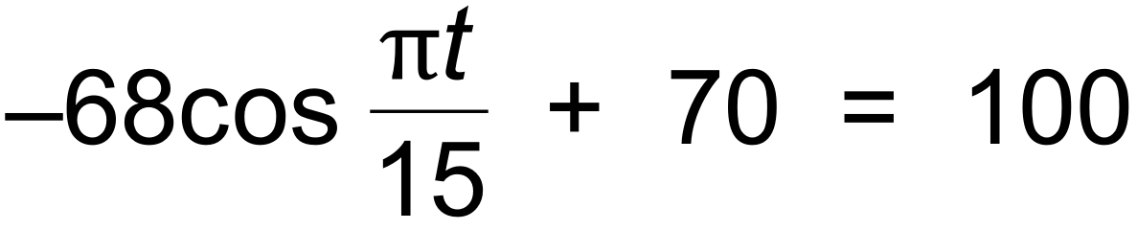
∴ t = 9.68, 20.32
∴ 10.64 minutes [7]

19. (a) It is given that 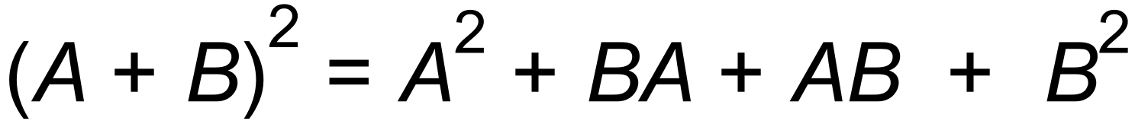
Since AB  BA,
∴ 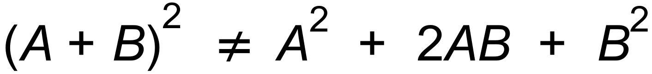
(b) 
∴ 
∴ 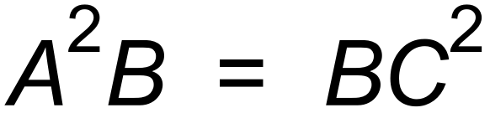
∴ 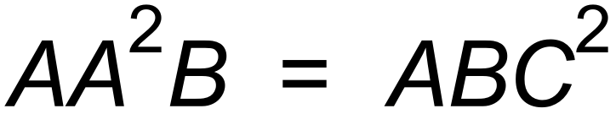
∴ 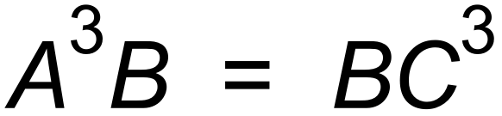
∴ 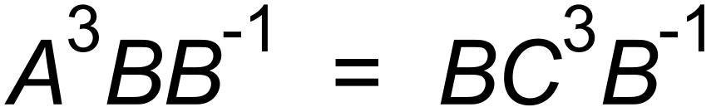
∴ 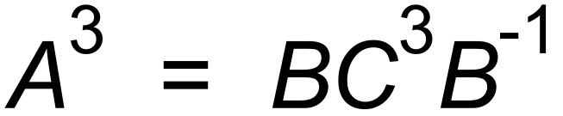 as required [6]

20. (a) 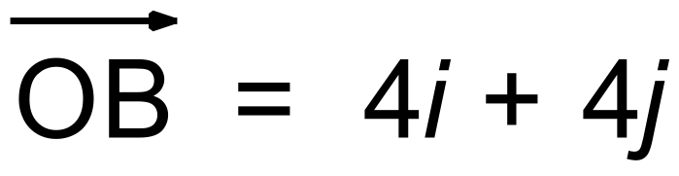
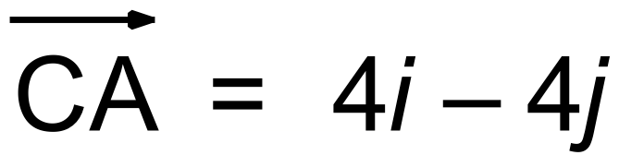
(b)
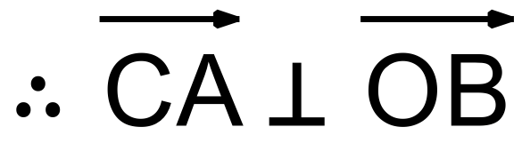
(c) Let k be the midpoint of 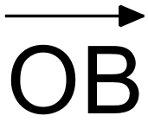.
Then K = (2, 2)
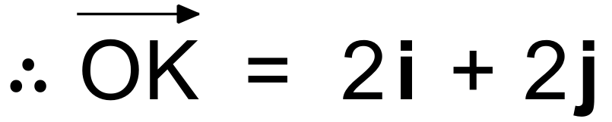
So
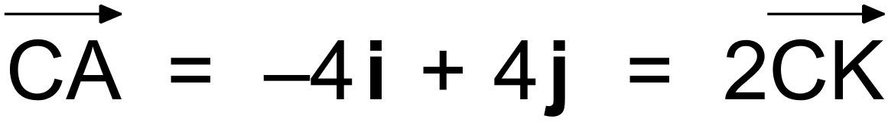
∴ K is the midpoint of 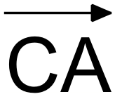 [7]
∴ Diagonals bisect each other.

